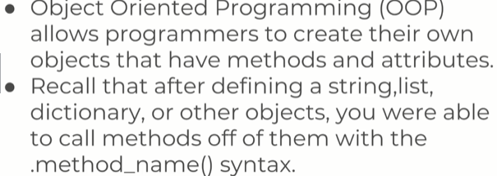

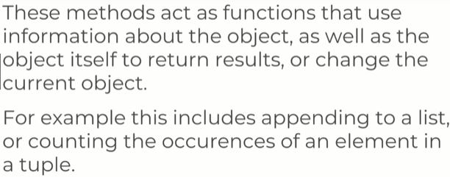

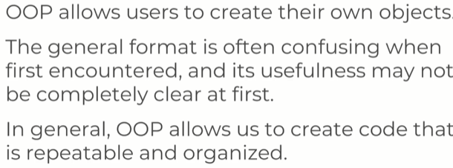

You need to learn OOP to make sure your program itself are flexible.
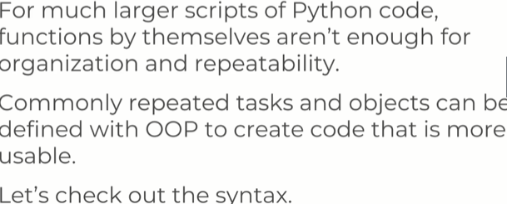

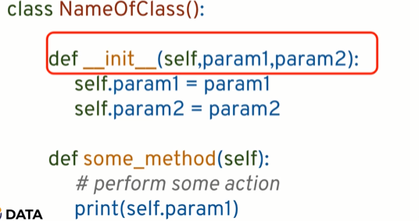

The red box is a thing that looks a lot like a function, but its called a method when inside a class.
We have _ _ init_ _ method , this allows us to create an instance of the actual object.
We have _ _ init _ _ ( self, param1, param2) , here param1 and param2 are the parameters that python wants u to pass. When u create an instance of this object.
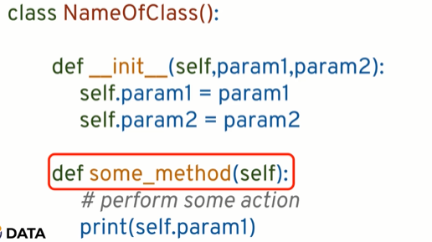

You pass the self keyword to let python know that this isnt some function, its a method that is connected to this class.

Object Oriented Programming – Attributes and Class Keyword
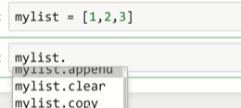
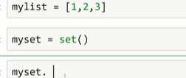
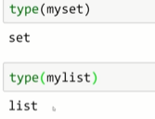

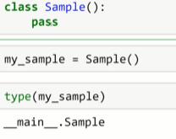

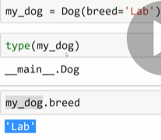

init can be thought of as a constructor for a class and its gonna call automatically when u call an instance of a class. The self keyword represent the instance of the object itself and most OOP languages pass this as an hidden parameter on the method defined on the object.
In python, it doesnt do this, you have to do this explicitly.

Note: Later when u r a programmer and python being so flexible
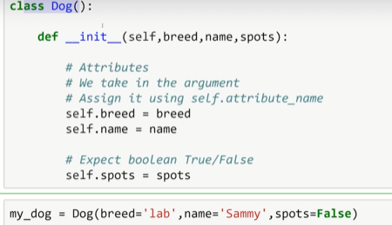

and you are expecting other people to use your Classes, you need to provide documentation to let them know that u r expecting
String for name, String for breed, Boolean for spots.
Cuz you can do this

and there is no type check.

OOP PART 2: CLASS object Attributes and Methods.

There are maybe attributes that are going to be the same for any instance of the dog class, we know it doesnt matter a dog has certain breed or certain name or spots.
Its always gonna be a mammal.
Something you wanna do, is define an attribute on class object level.
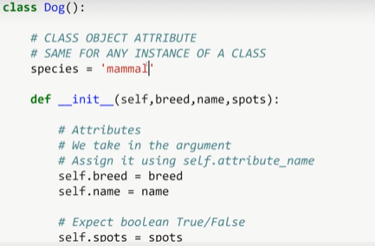

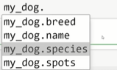

method is a function inside of a class, that will work on the object some way.
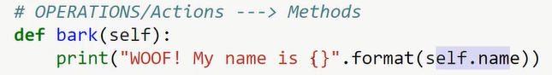
OOP Part 3 – inheritance and Polymorphism

inheritance is a way of forming new classes from the classes that were already defined.
The really important benefits of inheritance is the ability to reuse code that you already worked on and reduce complexity of a program.
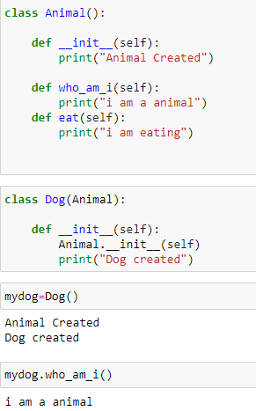

Polymorphism:
refers to the way that different object classes can share the same method name
and those methods can be called from the same place even though variety of different objects might be passed in.
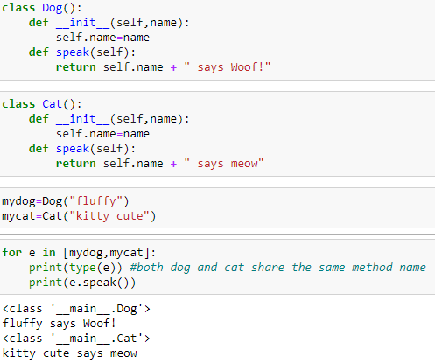

another e.g
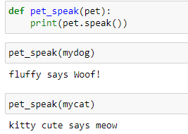

On both cases we are able to pass in different objects and we obtain object specific result from the same mechanism, same method call.
More common practice is to use abstract classes and inheritance.

An Abstract class is one which is never expect to be instantiated. Instead its only design to serve as a base class.

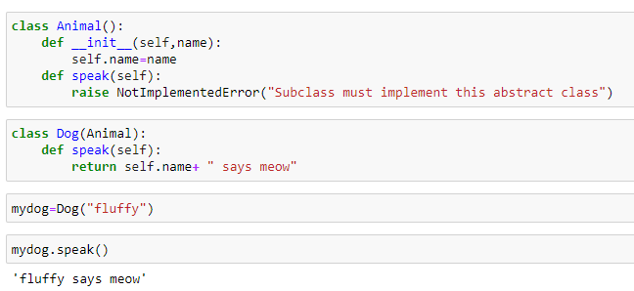
Real life e.g of polymorphism
- is opening different file types
So a method open() , but there is a lot of different files(pdf,excel).
You are trying to make a class thats a base class for opening files and u have other classes that inherit that. So for e.g a class for opening cdv, word , excel.

You want them to share the same method name <some class object>.open()

Object Oriented Programming P4 Special (Magic/dunder) Methods

Special methods allow us to use some built-in operation in python such as the length function or the print function with our own user created objects.
An e.g
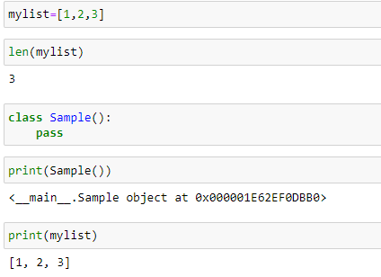

So the question is how am I able to use buit in python functions such as length or print with my own user defined object ?
Solution is Special methods or Magic or Dunder methods.
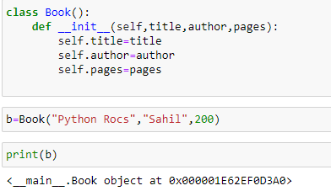

it just give the object location in memory
So what happens is, when u use print function, the print function ask what is the string representation of b

so if I try to transform b into a string, I got a string version of object memory location.
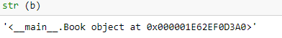

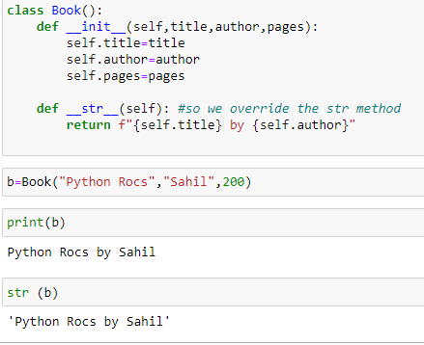

we got the same output from print and str; cuz the print function does is it prints out what is the String representation returns back.
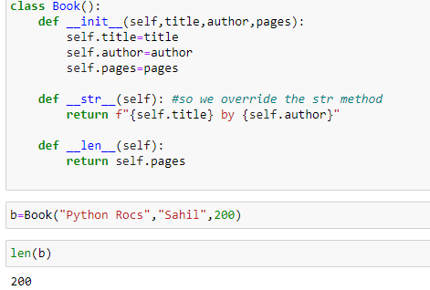

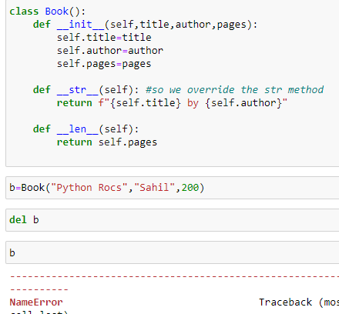

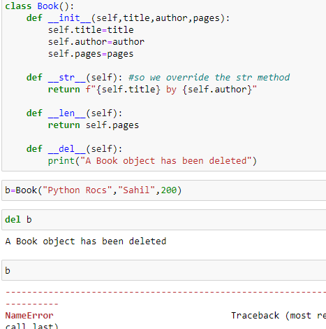

Decorators with Python overview
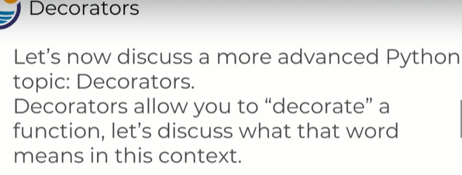
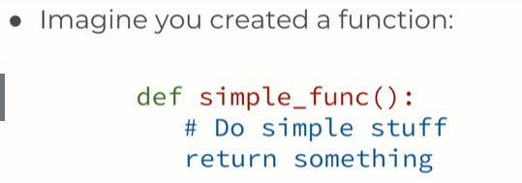

So u created this simple function and now you wanna add more functionality to it or IOW add more code.
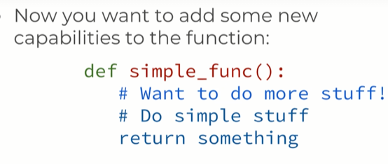

what you code do is take ur original simple func and adds some more stuff to it and keep doing the old stuff n return something

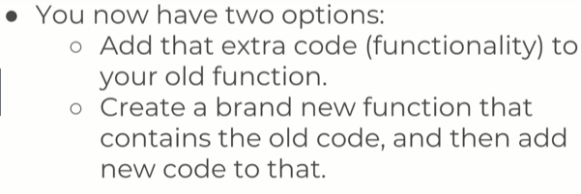

1. You have two options here, adding functionality to your old function but then you have a problem about not being able to call your original function.
You edited in someway with that new functionality.
2. Other way is to create a brand new func where you copy your old code and added your new code to that. The problem is now u have to recreate the entire function all over again.
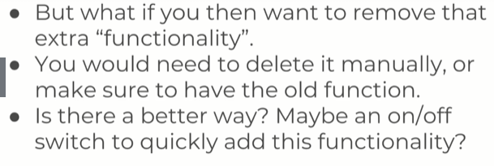
This is where a decorators come at play.
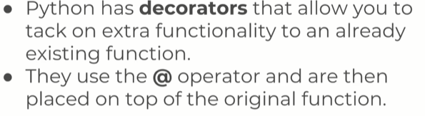
Now if u no longer want that function , u just delete the one line from the decorator.
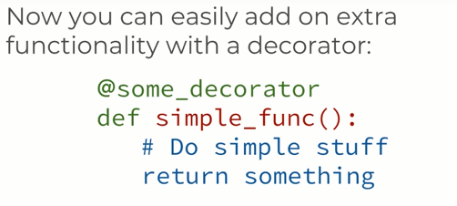

so
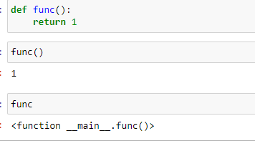

when u print a function, u’ll get info about “you have a function here”, you wont actually execute it.
That means we can assign func to other variables and execute them off the variable.
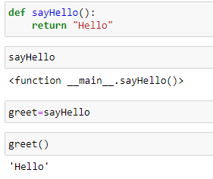
So what we gonna ask is greet pointing to sayHello? Or made his own copy of sayHello?

That is
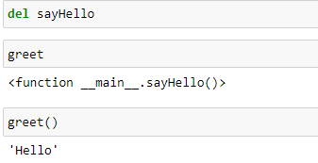
So even though we deleted sayHello, the name greet is actually still pointing to that original function object. Its important to note func and object can be passed into objects.

Having a func within a function.
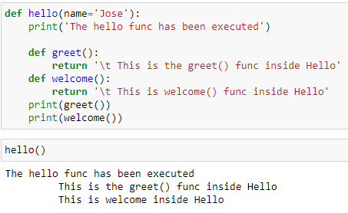

One thing to notice, is greet() and welcome() is only defined inside the hello func, not outside. That means there scope is limited to hello() func .
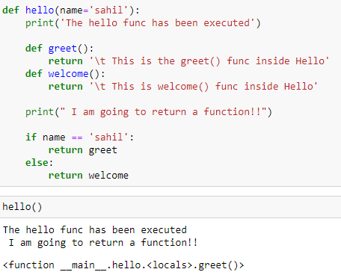

we can assign the func that is returned to a variable.
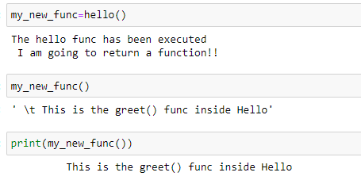

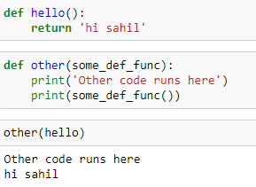

So decorators starts now
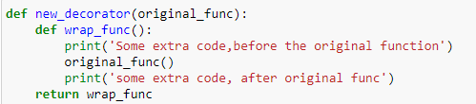

You can think about this as a present with some wrapping paper, the original func is the present we gonna put essentially inside a box and wrap around it, this why its called decoration.
Wrapping paper is some extra code that goes on top of the func or after it below the func.

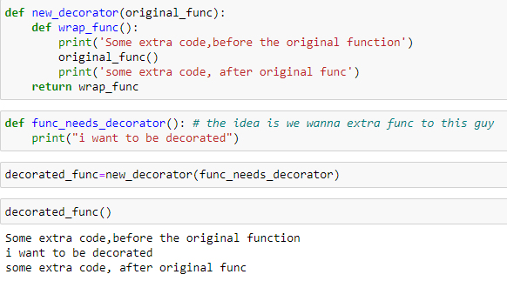
Easier way Using decorator is:
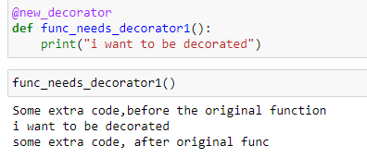

Using decorator u didnt need to pass the func to be decorated inside a decorator and then assign it to a variable.
Now u just can “ @new_decorator” you can easily decorate and remove decorate by
removing this line.

Generators
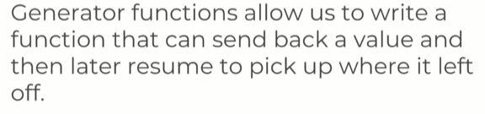

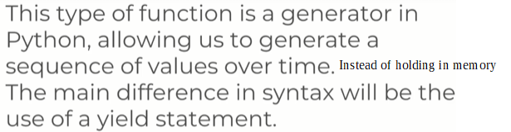
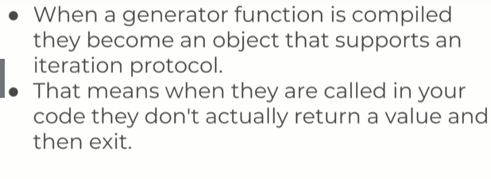
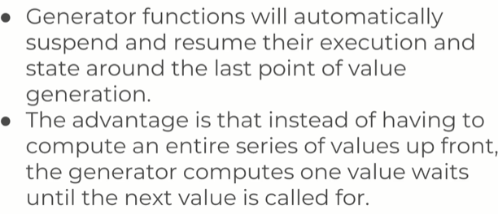

So you can imagine you want all the number between 1 and 1 million.
You have 2 options here, you can either start generating values 1,2,3,4 feed them that way in a for loop.
Or
Create a giant list of no from 1 to million and slowly pickup the numbers from the memory.
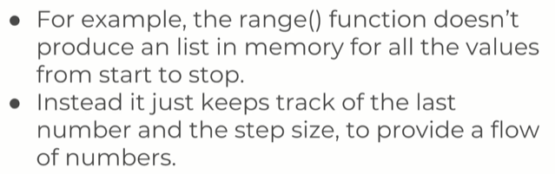
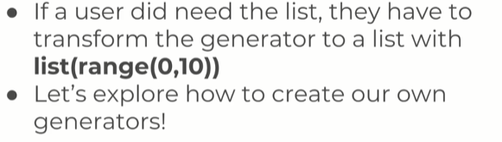
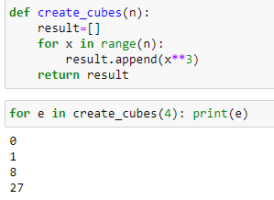

what happens when we print them, is actually we only needed one value at a time to print them we dont need the whole list store in memory. In fact, we only need the previous value and whatever the formula is to get the next value in order to generate all these cubes.

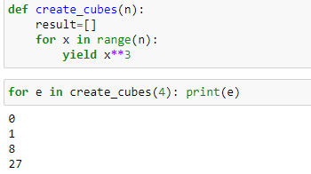

now create cubes is way more memory efficient, b4 we have to store the entire list of no in memory. But now , we dont have that list in memory so we are yeilding the value as they come, so create cubes here is a generator.
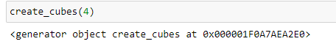

keep in mind, if u call createCube itself, you dont see the list. You only see there is a generator object in memory and u have iterate through if u want the actual numbers.

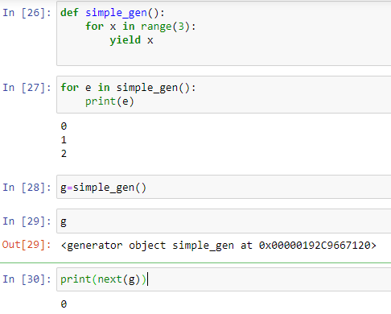

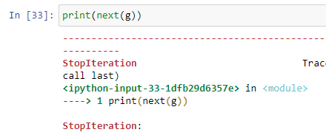

This error tell us, all the value have been yielded.
We dont get this error when using the for-loop, cuz for-loop automatically catches this error and stop calling next.
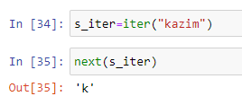

Modules and Packages
Pip install and PyPi
PyPI is a repository for open source third-party python packages.
It’s similar to RubyGems in the Ruby world, PHP’s Packagist, CPAN for pearl, and NPM for Node.js
There are many other libraries available that people have open-sourced and shared on PyPi.
We can use pip install at the command line to install these packages.
By installing python from python.org or through the Anacondo distribution you also installed pip.
Pip is a simple way to download packages at your CLI directly from the PyPi repository.
There are packages already created for almost any use case you can think of!
A quick google search will usually help you to discover a link to the PyPi page for the package, or for the package documentation.
For e.g, you wanna make web development with python, you may wanna google around. You will discover there is libraries Django and flask for web development.
You may a very specific usecases, like working with pdf with python or working with excel documentation.
How to install package that is on PyPi.
Your firewall may block pip from accessing the internet, so if you are on work computer or network, you may need admin permissions or talk to your network administrator.
> pip install requests
which allows you to request info from website online

>pip install colorama
>>> from colorama import init
>>> init()
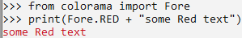
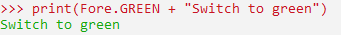

How to fish?
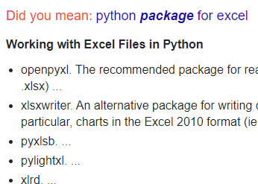

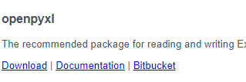

On download page you’ll find documentation form python.org.
With another link to the official documentation of openpyxl.

Modules and Packages
how to write your own modules and packages.
Modules are just .py scripts.
Its just a fancy way of saying heres the .py scirpt that I am using with anoth .py script. So the act of using It in another .py scripts allows you to call it a module.
Packages are a collection of midules.
However there is a key .py script called __init__.py that needs to be placed inside a folder to let them know that this is collection of .py scripts.
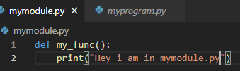

The idea is that if you have a really large script, you are not going to put everything in one giant .py file. Instead it will be nice if we split it up between multiple .py files.
Which means split between different modules.
Later we can aggregate bunch of modules to create a package.
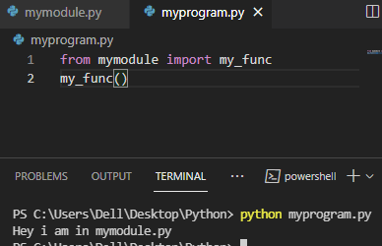

So we do the above, so we don’t have it all in one py script.
At some point, this is gonna be too much and you wanna aggregate modules together to form a packaged, and that way you can different folders for different packages.

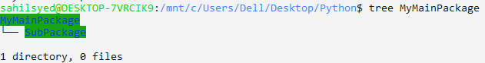
Since these are directories and folders, not just as a normal directory but as an actual package.
To do that I would create inside MyMainPackage a __init__ file.
We don’t need to write anything in this file, it just needs to be there so that when python goes searching through these packages, it understands, its not a normal dir its a package.
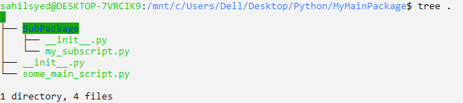
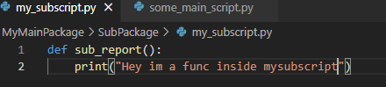

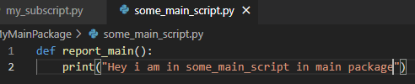

Think of program.py as the main py script you wanna run. I want to organize my files In packages.
So rn, we’ve explored how to actually create a single module, which is just that pie script.
So imagine importing from various module, various .py scripts.
But at certain point its going to be too much and we want to organize them into folders.
So there is packages which are directories which have __init__.py, which tells python this packages has bunch of modules in it. You can call them.
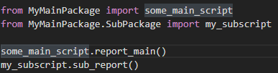

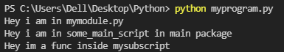

As you get better and better in python, so at the beginning you’ll create a couple of modules that all be in the same folder.
As it starts getting more and more unwieldy to have it all in the same folder. All you need to do is create directories that have __init__.py that tells python its a package.

__name__ and __main__
An often confusing part of python is a mysterious line of code
if __name__=”__main__”
Sometimes when you are importing from a module, you would like to know whether the module function is being used as an an import, or if you are using the original .py file of that module.
Working:
All the code that is at indentation level zero (zero tabs) is gonna run. Leading all ur statements and functions are gonna be defined.
Unlike other languages, in python theres no main function that you call somewhere at the top of the script that gets run automatically.
Implicitly all the code at indentation level zero, runs when you call the script file.
In python, there is built in variable called name.
Built in variables have two set of underscores at the beginning and in the back of it.
So what happens is this, var name gets assigned a string depending on how you’re running the actual script.
So if I run the script directly I.e
> python one.py
what would happen is,
__name_=”__main__”
so we do
if ( __name_=”__main__”):
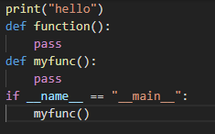

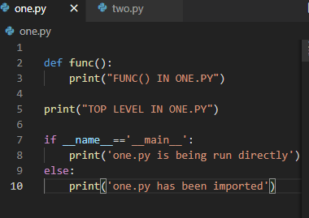
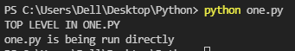

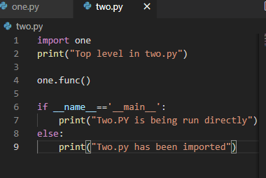
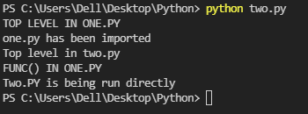

All this was for code organization.

Errors and Exception handling
Errors are bound to happen in your code.
Especially when some1 else ends up using it in an unexpected way.
We can use error handling to attempt to plan for possible errors.
For e.g, a user may try to write to a file that was only opened in mode=’r’. So if there is any error. The entire script is gonna stop and return error.
We can use error handling and let script return to the other code and report the error.
So even if there is an error the code will report the error and continue on.
We use three keywords for this:
try: this is the block of code to be attempted (may lead to an error)
except: block of code will execute in case there is an error in try block.
Finally: A final block of code to be executed, regardless of an error.
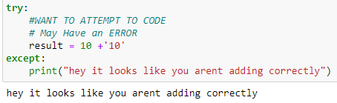

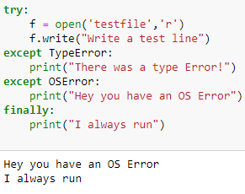
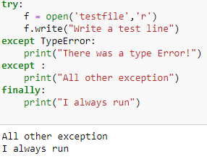

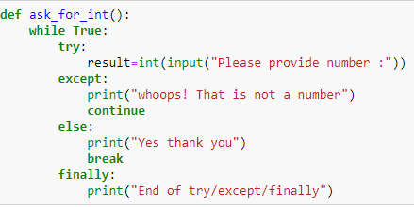

Pylint Overview
Unit testing
As you begin to expand to larger multi-file projects it becomes important to have tests in place.
This way as you make change or update your code, you can run your test files to make sure previous code still runs as expected.
There are several testing tools, we will focus on two:
pylint : This is a library that looks at your code and reports back possible issues.
Unittest :This built-in library will allow to test your own programs and check you are getting desired outputs.
We gonna learn how to use pylint to check code for possible errors and styling.
Python has a set of style convention rules known as “PEP 8”

>pip install pylint --user
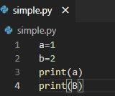

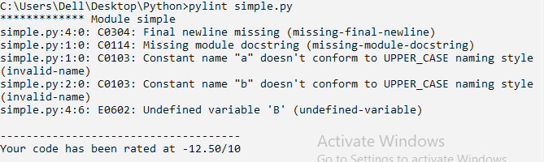
it also give statistics, Raw metrics( code,docstring,comment,empty), duplication,
message by category(conventions,refactor,warning,error)

Running test with the unittest library
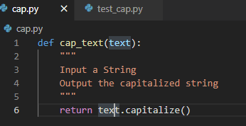

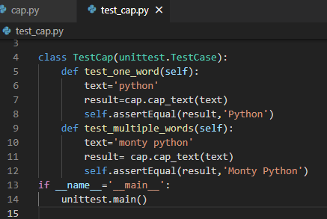

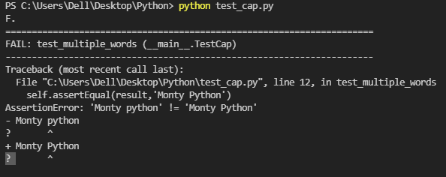
There is always somebody in Quality Assurance actually writing these test to make sure that your script work as they expect them to.

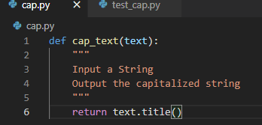
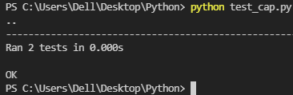

So you have your scripts and this could be lots of scripts, could be a single script and you call functions or classess or whatever you want, and then inside of your testing script, you are going to import unit test, import any of these scripts you’ve been working on, create a class for testing.
You’re going to inherit from unittest.TestCase andthen your going to have methods to test.
You would use AssertEqual I.e is the result im getting from the script the expected result.

Advanced python modules
Python has several built-in modules.
Modules covered
- Collections
- Os module and Datetime
- Math and Random
- Python debugger
- Timeit
- Regular expressions
- Unzipping and Zipping modules

Python Collection module
Its built-in.
It implements specialized container data types that are essentially alternatives to python built-in containers that are just for general purpose.
What I mean by container is something like dictionary or a tuple.
1.Counter
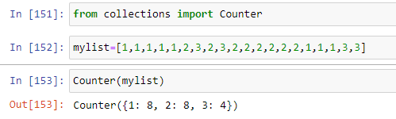

Counter is a subclass of dictionary.
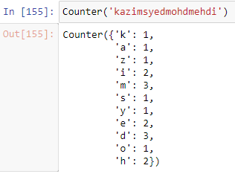

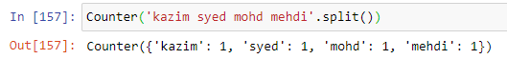

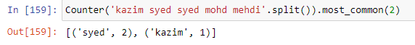
2. Default dictionary
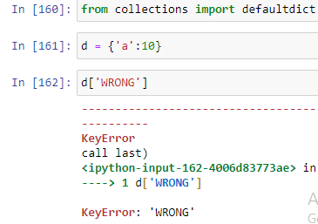

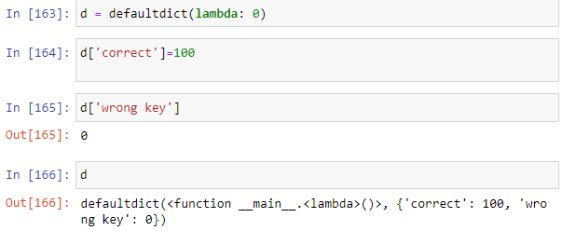

3.namedtuple
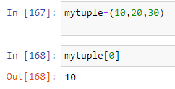
Having a large tuple and not knowing what value is at what index.
So namedtuple wont just have numeric connection with the value, but it would also have named index.
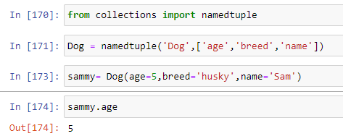

Opening and Reading files and folders (Python Os modules)
We already know how to open an individual file with python, but we still don’t know how to do a few things:
- What if we have to open every file in a directory and read and write to it. How do we find those correct directories and loop through them ( subfolders within subfolders).
- What if we want to actually move files around on ur computer.
Python’s os module and shutil(shell utility) allow us to easily navigate files and directories on the computer and then perform actions on them, such as moving and deleting them.
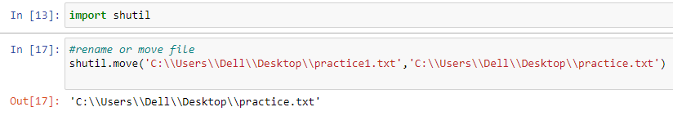
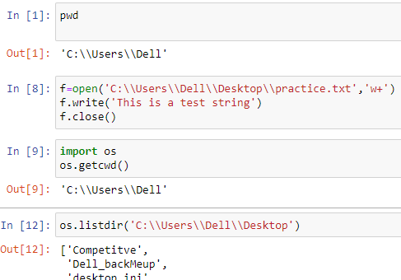

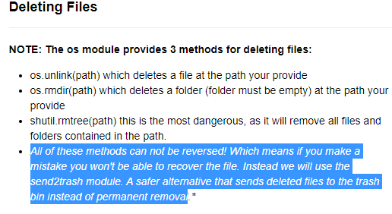

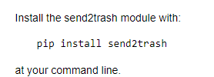

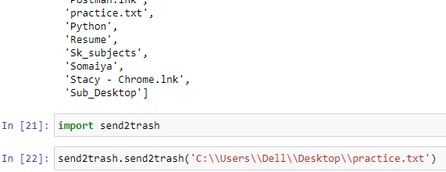
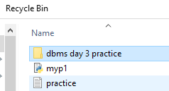

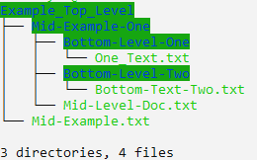

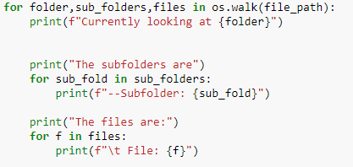

[ (Example_top_level, Mid-Example-One,Mid-Example.txt),
(Mid-Example-One, Bottom-level-one+Bottom-level-two, mid-level-doc.txt)
...
]

Python datetime module
It allows you to create objects which has information not just the data and time but also TZ and operations between datetime objects, how many days,sec has passed.
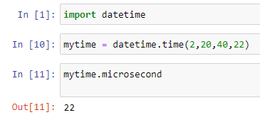

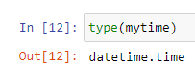
We see it only info about time, it doesn’t have date associated with this.
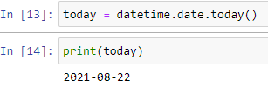
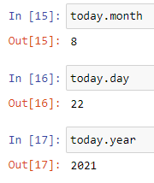

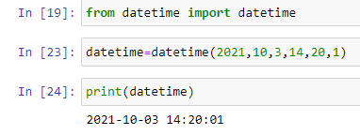

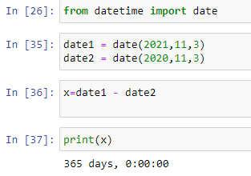
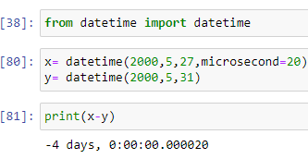

Math and Random modules
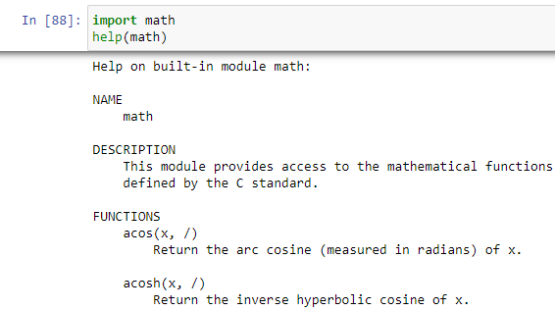

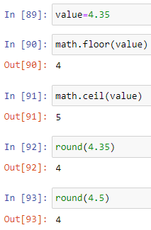

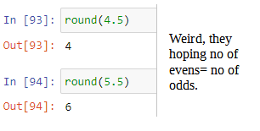

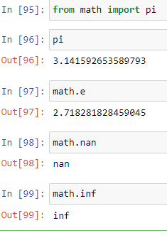

Numpy for heavy mathematics.
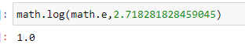
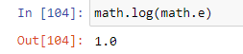

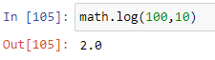

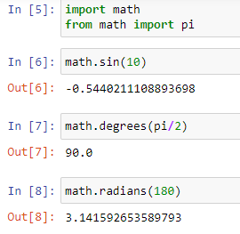

Random module:
allow us to create random numbers and we can even set a seed to produce the same random set everytime.
Seed:
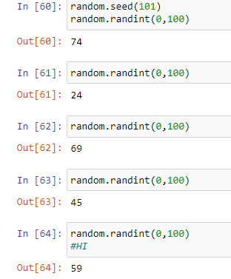
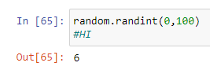

random.randint(0,100), probability we got the same number is 1/100.
What seed does is?
Its a batch of same random numbers.
For seed(101),
[74,24,69,45,59,6,…..]

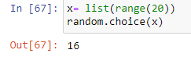
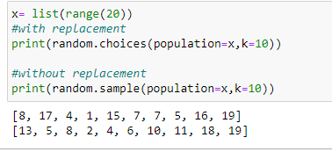

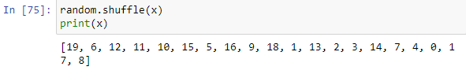

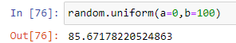

This is a continious distribution, that means floating points are allowed.
The reason it is called uniform, cuz the no’s between 0-100 have the same likelihood to be choosen.
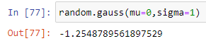
Mean=0, sigma is S.D

Python Debugger
When trying to figure out what errors there are in your code, you’ve probably used print() to try to track down the error.
Fortunately, Python comes with a built-in debugger tool that allows you to interactively explore variables within mid-operation of your Python code.
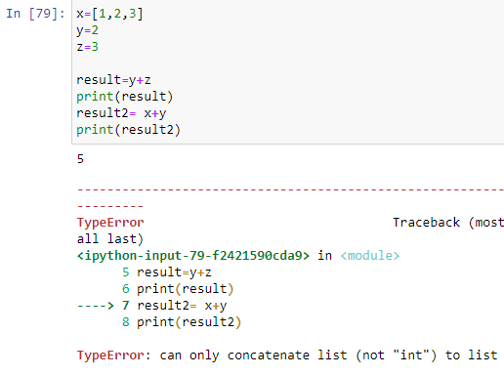

Instead of using the print function as you did b4 or you could set a trace, using the
python debugger.
The trace is gonna pause the operation midscript and allow you to play with variable, instead of adding print functions.
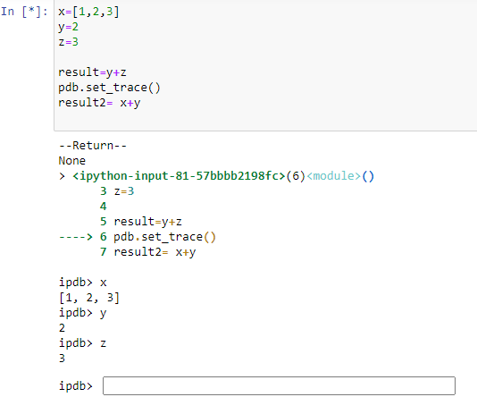

Python: Debugger
Video:youtube
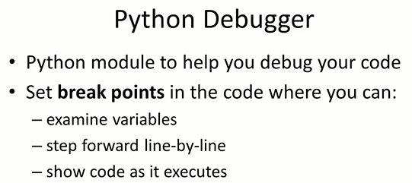

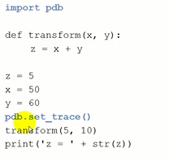

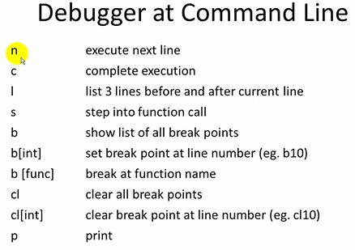

Above, you do p().

Python Regular expression Part One
We already know we can search for substrings within a larger string with the in operator.
“dog” in “my dog is great”
>True
Limitations:
we need to know the exact string, and need to perform additional operations to account for captilization and punctuation.
What if we only know the pattern structure of the string we’re looking for?
Like an email or phone number.
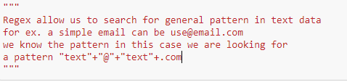

The re library allows us to create specialized pattern string and then search for patterns within text.
The primary skill set for regex is understanding the special syntax for these pattern strings.
For e.g
Phone number : (555) – 555 – 5555
Regex Pattern: r”(\d\d\d) - \d\d\d - \d\d\d\d”
Regex Pattern: r”(\d{3} - \d{3} - \d {4})”
{3},{4} are called quantifiers.
the r informs python that don’t treat it as normal string that there is identifiers within the strings.
The backward slash (“\”) indicates these are individual identifiers.

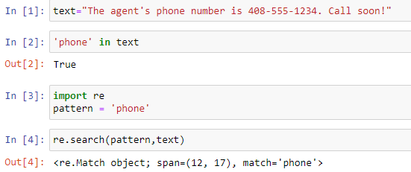

span tells the start-index,end-index of search pattern.
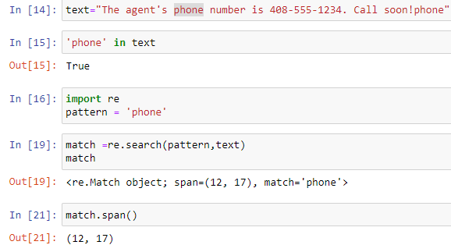
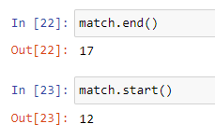
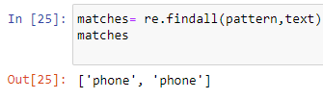

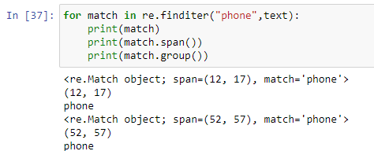

Regular expression part two
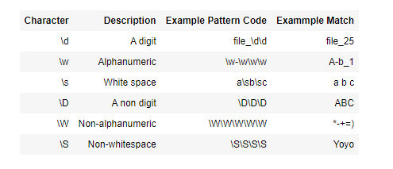
Identifiers for characters in Patterns

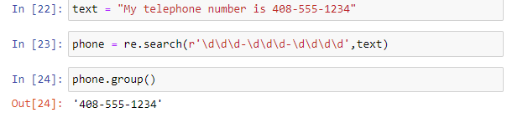
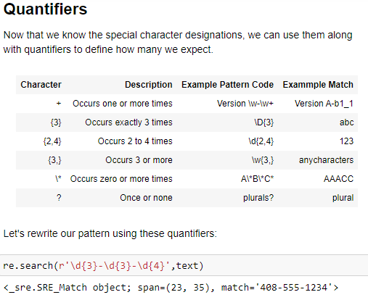

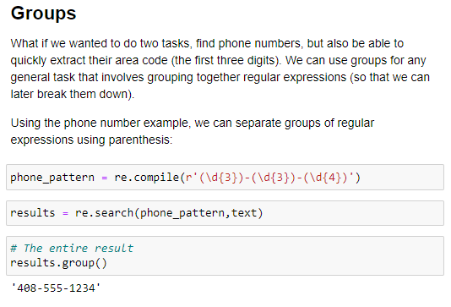

# Can then also call by group position.
# remember groups were separated by parenthesis ()
# Something to note is that group ordering starts at 1. Passing in 0 returns everything
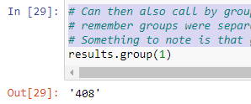

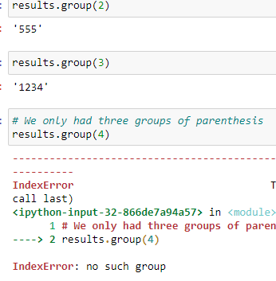

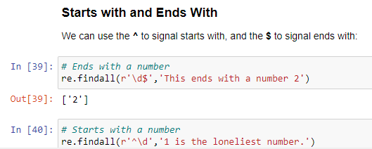

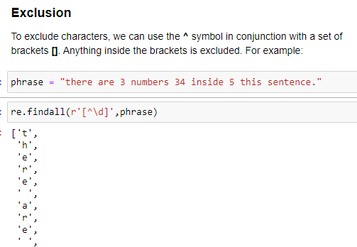

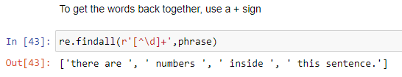

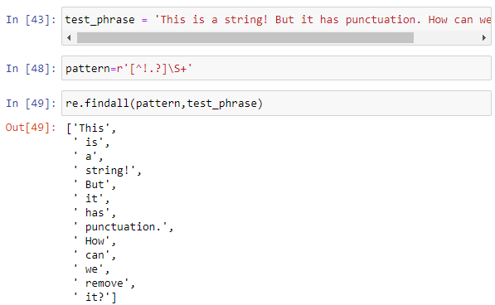
i made a mistake above, it allows whitespace b4 text.
Above only avoids white space, when it finds a punctuation first
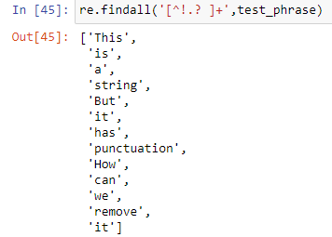

Timing your python code
As you learn more python, you will discover multiple solutions for a single task and you may find yourself trying to figure out the most efficient approach.
An easy way to do this is to time your code’s performance.
We will focus on 3 ways of doing this:
- Simple tracking time elapsed.
Limitations: if ur func is very fast or small problem.
- Using the timeit module
- Special %%timeit “magic” for jupyter notebooks
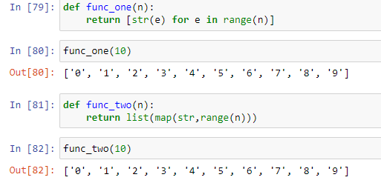

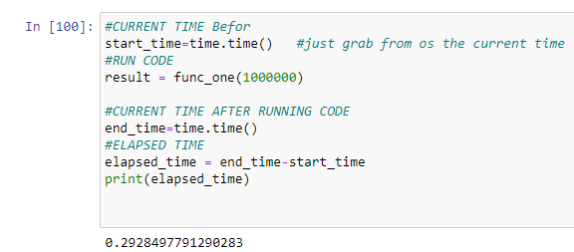

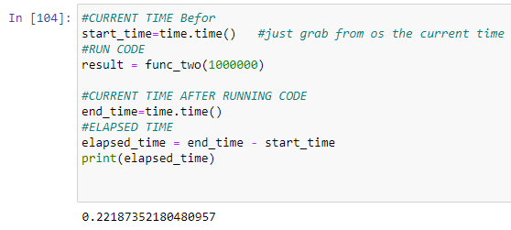

Function two is slightly faster than function one.
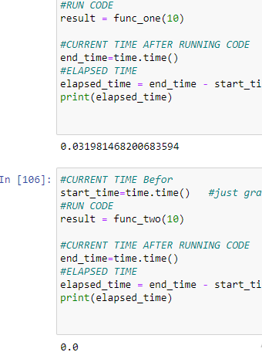

timeit
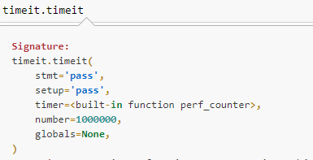

the stmt and setup are passed in as string.
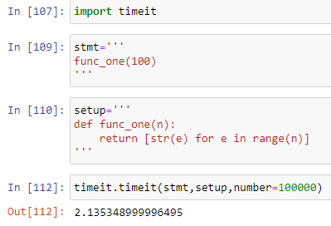

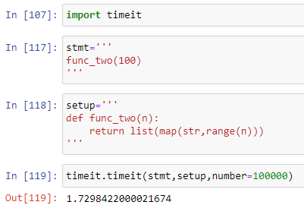

In jupyter:
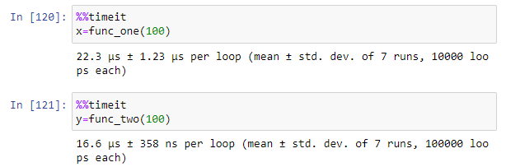
you dont need to do setup, its implicitly gonna check the previous cell for the method definition.

Unzipping and Zipping files
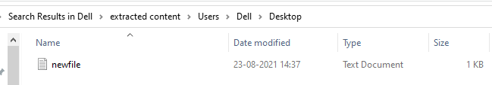
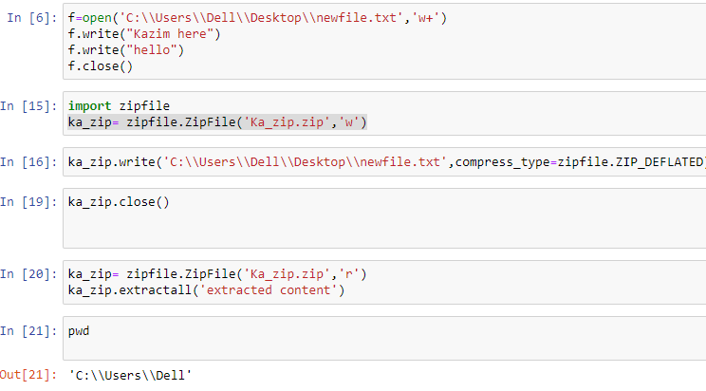
shell utility
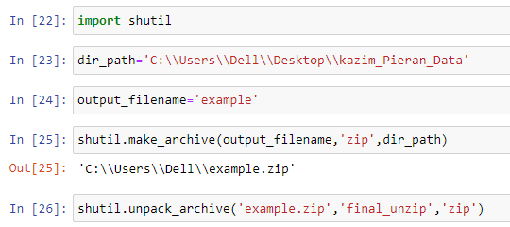

Introduction to web scraping

Wikipedia is html+css+js code.
We gonna use python web scraping program.
To grab what we want, maybe the wikipedia logo.
So, we be able to search through the html documents and find
logo images, such as jpeg, png files, something from html doc.
Grab information from website and convert it into python objects
Main things we need to understand
Rules of Web scraping
Limitations of Web Scraping
Basic HTML and CSS
Rules of Web Scraping
- Always try to get permission before scraping.
- If you make too many scraping attempts or request your ip address could be blocked.
- Some sites automatically block scraping software
Limitations of Web Scraping
- In general every website is unique which means every web scraping script is unique.
- A slight change or update to a website may completely break your web scraping script.
So the script are pretty static and they not gonna be able to adjust to changes in the websites. This is something that is annoying about web scraping. So if you plan to have a long time web scraping project, its more than likely you gonna have to make adjustments to that script overtime.

Our goal in this section of the course, is to be able to generalize the skillset using python to perform web scraping so you can take the general ideas and apply them to websites, instead of copying some cookie-cutter code.
What we want you to do, is looking up the information and generalizing the process of webscraping, so you can apply it to unique solutions.
--
So when viewing the website, the browser doesnt show you all the source code behind the website, instead it show you the html and some CSS and JS that the website sends to your browser.
--
To web scrape with Python we can use the BeautifulSoup and request libraries.
These are external libraries outside of python so you need to install them with either anaconda or pip at your CLI.
--
>pip install requests lxml bs4
request is used to make request to a website and grab information out of it.
Lxml which is later gonna be used by bs4 essentially to decipher when text returns.
bs4 is BeautifulSoup

Python Web Scraping - Grabbing a Title.
Use the jupyter notebook: Guide to webscraping
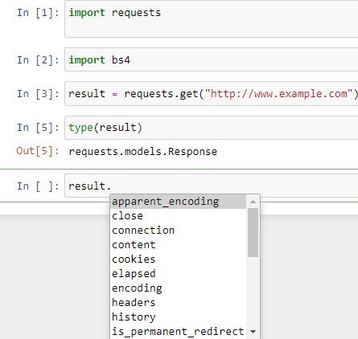

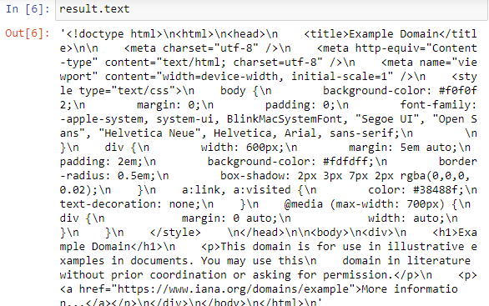
Anything i can do with python string i can do this with this large text.
In order to pass through this, is used bs4.
Its gonna allow us to obtain information easily.
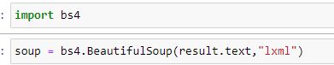

The Second argument is What engine to use, to parse this String.
Bs4 uses this to know what is the css class, id, which are the different html elements and tags, etc.
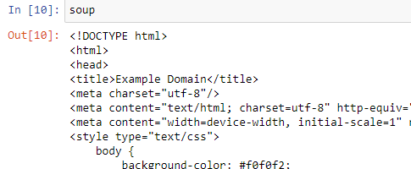

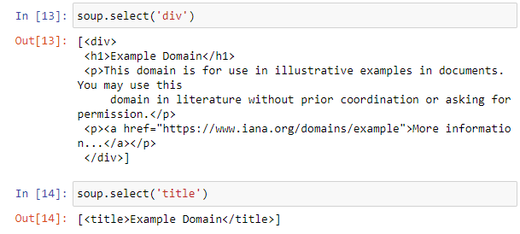

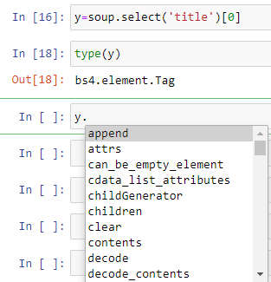

Python Web Scraping – Grabbing a class
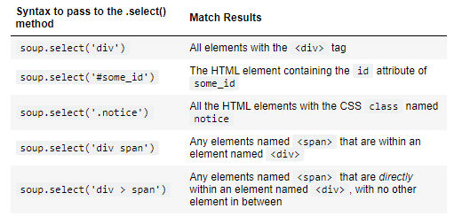

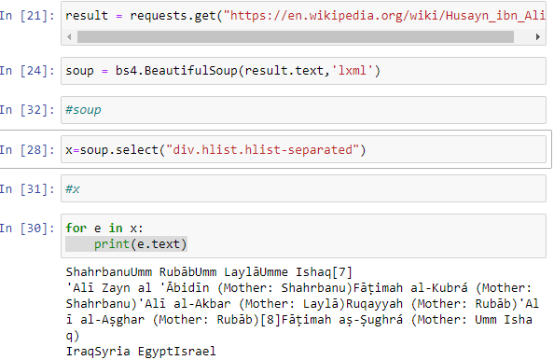

Python Web Scraping – Grabbing an image
Images on a website typically have their own URL link ending with .jpg or .png
bs4 can scan a page, locate the <img> tags and grab these URLs. Then we can download the URLs as images and write them to the computer.
Note: You should always check copyright permission before downloading and using an image from website.
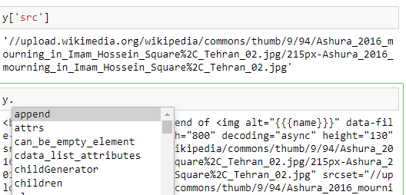

In jupyter notebook
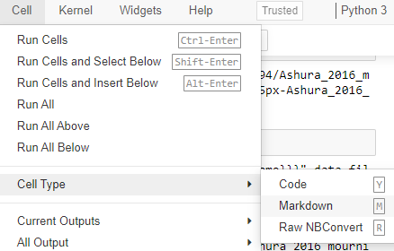

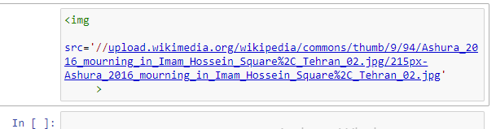

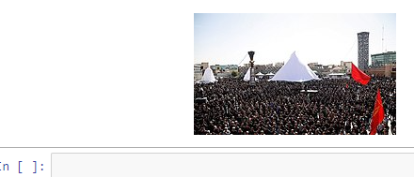

Let say they change the image or remove it. Lets say we dont wanna be dependent on this website. Or we need it for school presentation.
How to download image
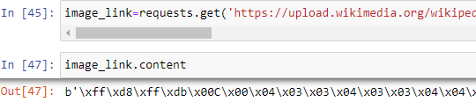

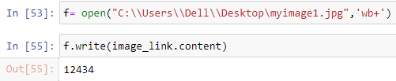

Python Web Scraping – Book Examples Part one
We’ve seen how to grab elements one at a time, but realistically, we want to be able to grab multiple elements, most likely across multiple pages.
We will use a site specifically designed to practice web scraping:
https://toscrape.com/
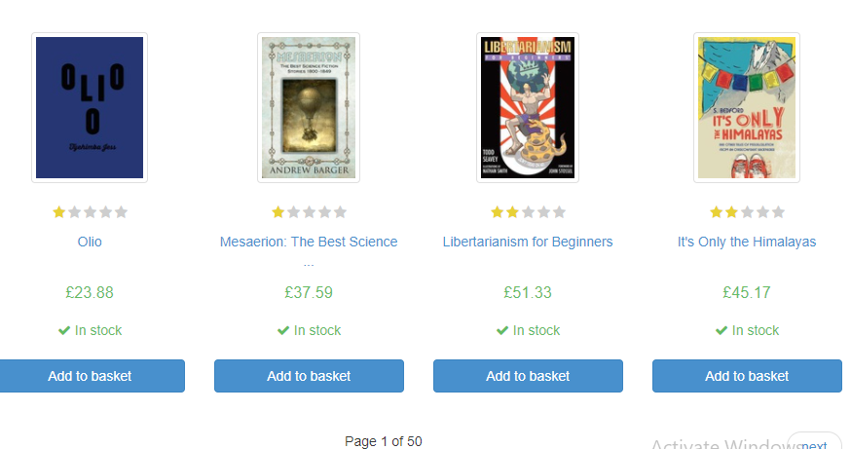

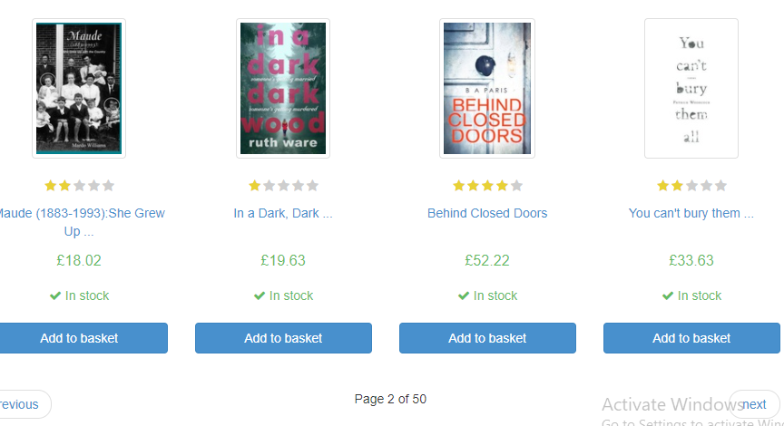

What i need to figure out?
Is possibly how to use python to keep going through these pages and keep doing the web scraping necessary. Bec

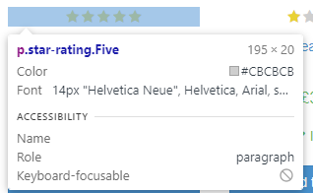

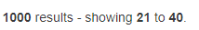
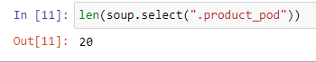

Dirty way:
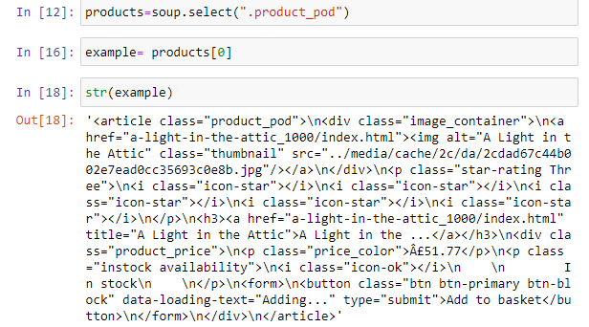

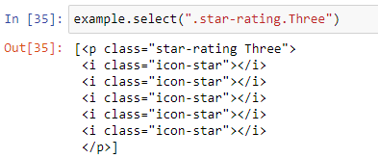

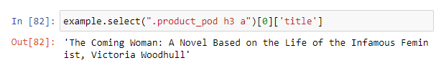

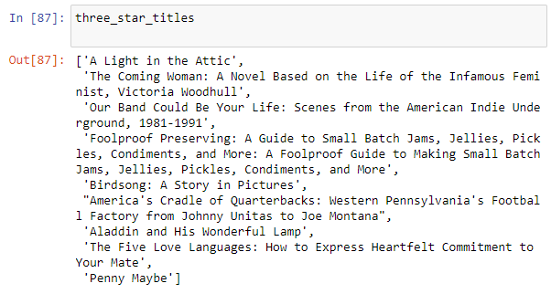

Working with images
Working with images with the Pillow library.
>pip install pillow
How to open,save, interact with image, grab sections of image or have an image overlap with another or have transparency in a image.

Working with images with python
We will gonna use the Pillow library for this, which is fork of the PIL (Python Imaging library) with easy to use function calls.
Official documentation:
- pillow.readthedocs.io
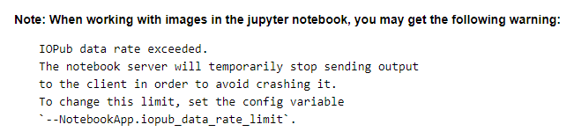
check the pieran data documentation.
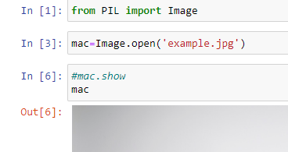
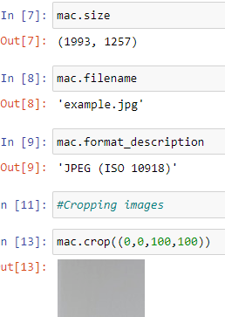

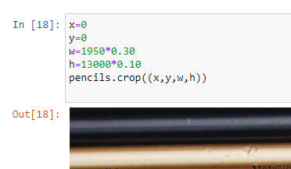

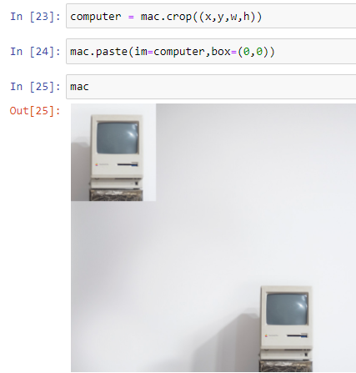

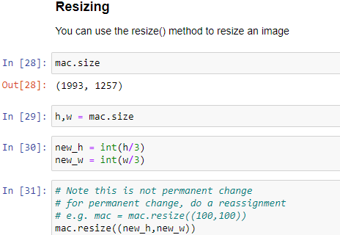

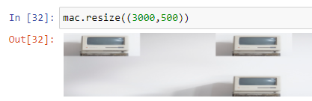
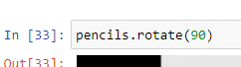

Alpha is transparency, zero means not there.
It ranges from 0 to 255.
>y =Image.open(‘x.png)
>y.putalpha(255)
You can put two images on top of each other using paste. Since transparency is der, the colors get mixed.
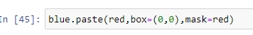

jose said the mask is gonna be same as the image, thats it.
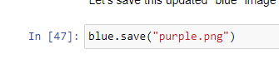

Introduction to pdfs and spreadsheet in python
CSV stands for comma seperated variables and is a very common output for spreadsheet program.
Example:
Name, Hours , Rate
kazim, 50, 20
Sahil, 30, 35
Each subsequent row represents a datapoint. Such as david work 20 hours at 15 dollar per hour rate.
All the columns are seperated by the commas.
Note, that while its possible to export excel files and Google Spreadsheets to .csv files, it only exports the information.
Things like formulas for a function, images, and general function macros can not be within a .csv file.
Simply put a .csv file only contains the raw data from a spreadsheet.
Other libraries to consider:
Pandas
Full data analysis library, can work with almost any tabular data type.
Runs visualizations and analysis.
One of Jose Portilla personal favourites.

Othe libraries to consider:
openpyxl
Designed specifically for Excel files
Retains a lot of Excel specific functionality
Support Excel formulas
python-excel.org tracks various other Excel based Python libraries.
Google Sheets Python API
Direct Python interface for working with Google spreadsheets
Allows you to directly make changes to the spreadsheet hosted online.
More complex syntax, but available in many programming languages.
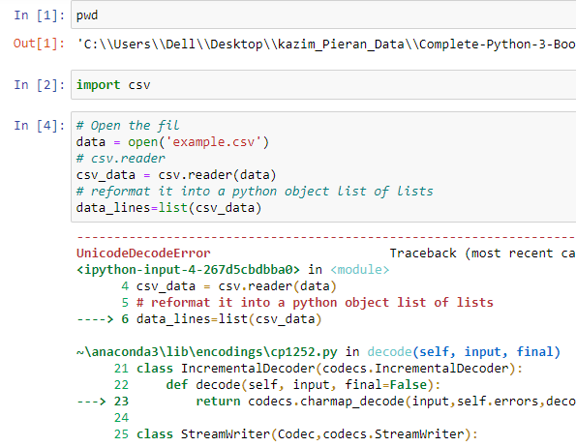

UnicodeDecodeError: 'charmap' codec can't decode byte 0x8d in position 1835: character maps to <undefined>
There is certain encoding a file can have, an encoding is basically be able to read or not read different types of special characters.
So the actual special character in this file is @, it contains emails.
You will find the same problem when dealing with files in another languages.
For e.g a spanish written file. You need to use proper encoding for that.

You can easily google search for correct encodings.
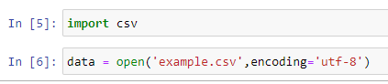

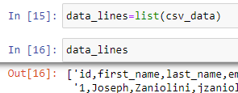

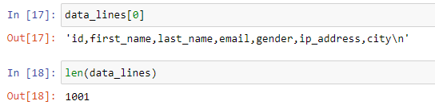

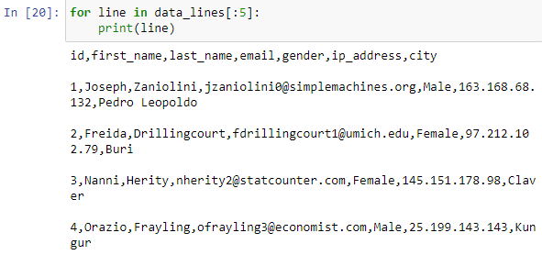

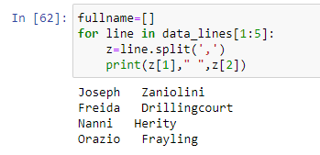

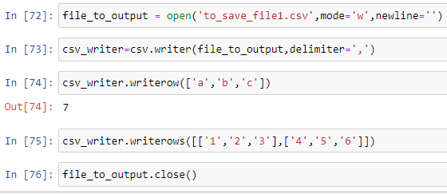

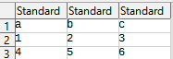

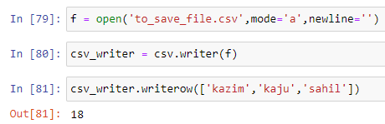

above mode a means append.
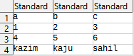

Working with PDF files in Python
PDF stands for Portable Document Format and was developed b Adobe in 90s.
Most important thing to keep in mind that while PDFs share the same extensions and can be viewed in PDF readers, many PDFs are not machine readable through python.
Since PDFs mainly encapsulate and display a fixed-layout flat document, there is no machine readable standard format, unlike csv files.
This means that a PDF that was simply scanned is highly unlikely to be readable.
Additions to PDFs such as images, tables, format adjustments can also render a PDF unreadable by Python.
There are many paid PDF programs that can read and extract from these files, but we will use the open source and free PyPDF2 library.
We’ve made sure that the PDF files included in this course material are readable by the PyPDF2.
> pip install PyPDF2
Follow Pieran data jupyter notebook, there is a link to other python libraries.
We can only read from pdf files, there are some specialized python libraries that attempt to write to a pdf file. That often result in errors.
We gonna be focused only on reading from pdf files, adding pages to pdf files.
And working on the text from pdf files.

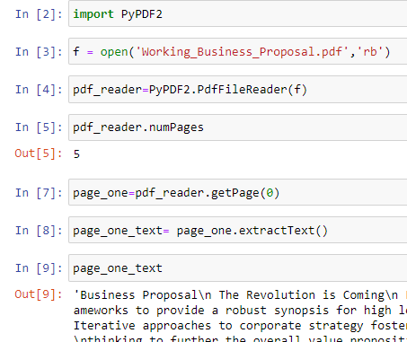

If you plan to read and write it should be a text,word document.
PDF are not designed to be easily editable.


